Data Visualizations of NYPD Arrest Data for 2023

Halleigh Kelchen  
halleighlkelchen@lewisu.edu  
DATA-53000, Spring 2024

Data Visualization Lewis University

# Introduction

New York, while a major city has one of the lowest crime rates relative to the United States. At the beginning of 2023, New York Police Department (NYPD) applied new precision policing methods to areas with high crime in an attempt to reduce crime [1]. This initiative included thousands of uniformed police officers on foot patrol in high-risk neighborhoods [1]. Continued overall reduction in five of the seven major index-crime categories was seen in 2023 compared to 2022 [1]. The arrest rate increased across all crime categories in 2023 likely due to the new boots-on-the-ground initiative [1]. The NYPD publishes their crime data for th public to study police enforcement data per year [2]. This report uses multiple data visualizations for exploratory analysis, intending to visualize different attributes and see overall trends in the NYPD arrest data for 2023.

# Data Description

The dataset used for this study is from the NYPD containing 226,872 instances of arrests [2]. Every record in the dataset represents an arrest made by the NYPD and includes relevant information about the nature of the crime, time, date, and location in which it occurred [2]. Data visualization will be used to interpret the large amount of data provided in this dataset. This data was made available to the public to monitor trends and the nature of police enforcement in New York City. It has also been used to create reports and analyses for the NYPD. Aside from this, not much has been done or published using this data. Table I, below identifies the 15 attributes included in the dataset. The number of arrests for 2023 is the main target variable for this dataset.

1. Data Attributes

| **Attribute** | **Type** | **Example Value** | **Description** |
| --- | --- | --- | --- |
| Arrest Key | Ordinal | 26911322 | Randomly generated ID for each arrest |
| Arrest Date | Ordinal | 5/6/23 | Date of arrest for reported event |
| PD Code | Numerical | 101 | Three-digit internal classification code |
| PD Description | Categorical | Assault 3 | Description of internal classification corresponding with PD code |
| KY Code | Numerical | 344 | Three-digit internal classification code (more general category than PD code) |
| Offense Description | Categorical | Dangerous Drugs | Description of internal classification corresponding with KY code |
| Law Code | Ordinal | PL 1200001 | Law code charges corresponding yo NYS Penal Law, VTL, and other local laws |
| Arrest Boro | Categorical | Manhattan (M) | New York Boro where the arrest occurred |
| Arrest Precinct | Numerical | 42 | Precinct number that handled the arrest |
| Age Group | Ordinal | 25-44 | Age range of the offender |
| Perp Sex | Categorical | Male | Sex of offender |
| Perp Race | Categorical | White | Race of offender |
| Number of Arrests | Numerical | 1 | Number of arrests made by NYPD in 2023 |
| Latitude | Numerical | 40.752050 | Latitude coordinates of where arrest occurred |
| Longitude | Numerical | -73.927908 | Longitude coordinates of where arrest occurred |

# Methodology and results

The dataset was uploaded to Tableau and used to create different visuals to conduct an exploratory analysis and to see trend in the arrest data. In Fig.1 below, a visualization is used to compare the number of NYPD arrests in 2023 by race. From Fig 1, it is evident that people of color had the highest numbers of arrests by NYPD in 2023, followed by white Hispanics. Fig. 1 also shows that the number of arrests of black-Hispanics and Caucasians in 2023 was similar.

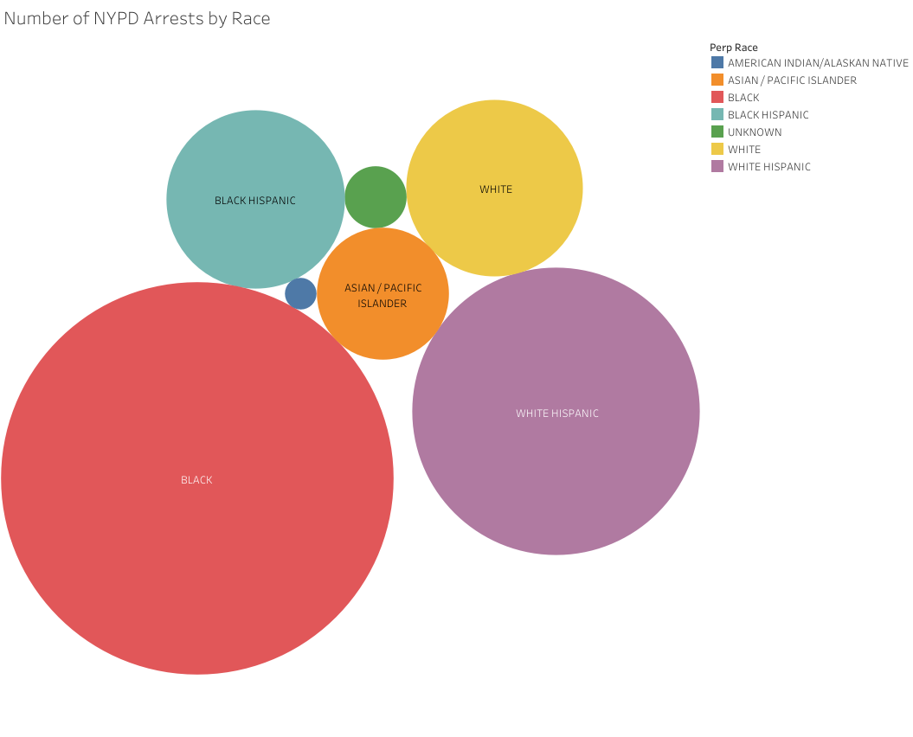

Fig. 1 Number of NYPD Arrests by Race

In Fig. 2, the number of NYPD arrests is shown by borough and age group. New York City is split up into five boroughs: the Bronx (B), Brooklyn (K), Manhattan (M), Queens (Q), and Staten Island (S). In Fig. 2, it is shown that Brooklyn had the highest number of arrests of the five boroughs. Fig. 2 also shows that a majority of the arrests across the different boroughs are people that fall into the 25-44 age group. As seen in Fig. 2, Staten Island has the lowest amount of crime of the five boroughs by a substantial amount.

Fig. 2 NYPD Arrests per Borough by Age Group

In Fig. 3, a tree map is used to examine the number of NYPD arrests by offense description. Based on Fig. 3, Assault 3 and related offenses had the highest number of arrests in 2023. Fig. 3 shows that petty larceny and felony assault also had many arrests. Dangerous drugs and miscellaneous penal law arrests are also in the top five most common offenses, as shown in Fig. 3.

Fig. 3 Number of NYPD Arrests by Offense Description

In Fig. 4, the sex demographics of the NYPD arrests were examined. As shown in Fig. 4, a majority of arrests made in 2023 were of males.

Fig. 4 Number of NYPD Arrests by Sex

In Fig. 5, the number of NYPD arrests per week was assessed. Based on Fig. 5, the second week of September seems to have had the highest number of arrests, followed closely by the first and last week of October. Fig. 5 also shows a drastic decrease in the number of arrests from mid-December to early January.

Fig. 5 Number of NYPD Arrest by Week

In a similar graph to Fig. 5, Fig. 6 shows the number of NYPD arrests per month separated by the different boroughs. As shown in Fig. 2 and Fig. 6, Staten Island has the lowest number of arrests of the five boroughs; the number of arrests for this borough is steady throughout the year. Fig. 6 also shows an increase in the amounts of arrests for the four other boroughs in May, August, and October. As seen in Fig. 6, the lowest amount of arrests take place in February and December.

Fig. 6 Number of NYPD Arrests by Month and Borough

# Discussion

Section III showed the different types of visualizations used to examine the attributes of the data. A bubble chart, pie chart, tree map, bar chart, and line chart were used to visualize and explain the NYPD arrest data from 2023. Different demographics, such as age group, sex, and race of offenders were examined and compared across types of offense and borough. In both Fig. 2 and Fig. 6, we saw that Staten Island had the lowest number of arrests of the five boroughs. In Fig. 2, we saw that the majority of arrests were of people aged 25-44. The analysis also showed that a large majority of arrests in 2023 were of people of color and males as shown in Fig. 1 and Fig. 4. Both Fig. 5 and Fig. 6 showed a large decrease in the number of arrests in the month of December through the end of the year. From these results, we can infer that the safest time to visit New York City would be during February or the holiday season in December in the 4 higher crime boroughs or year-round in Staten Island.

Using the content from this week’s lecture, the three-stage model of perception was used to create explanatory visualizations. One example of stage 2 is the use of different shades and sizes of blue boxes in the tree map in Fig. 3. From this figure, we can identify offenses with similar amounts of arrests based on the size and color of the boxes. This model was used to help choose colors, sizes, and different types of graphs to help the viewer process the different visualizations. Exploratory analysis was used to examine multiple variables individually to visually compare different demographics of offenders based on their arrest data. This analysis allowed for the different attributes to be visually compared and identified patterns in the arrest data that could be used for further analyses.

# Conclusions

In this report, a dataset from the NYPD of arrest data for 2023 was used to create visualizations and conduct exploratory analysis. Using these visualizations, common demographics of offenders and areas of high crime were able to be identified.

##### References

[1] *NYPD announces December 2023, end-of-year citywide crime statistics*. The official website of the City of New York. (2024, January 4). <https://www.nyc.gov/site/nypd/news/p00098/nypd-december-2023-end-of-year-citywide-crime-statistics>

[2] NYPD data.cityofnewyork.us. (2024, January 19). *NYPD arrest data (year to date)*. Catalog. <https://catalog.data.gov/dataset/nypd-arrest-data-year-to-date>